**SALAH TRACKER**

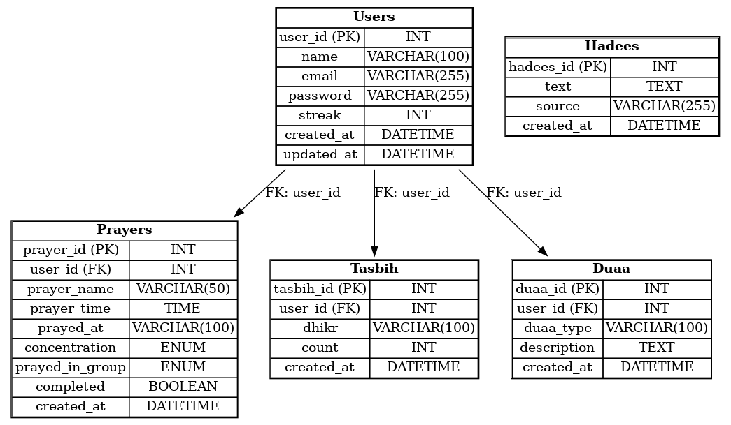

1. **Users and Prayers**
   * Relationship Type: One-to-Many
   * Explanation: One user can have multiple prayers recorded, but each prayer belongs to one user. This is achieved using the user_id as a foreign key in the Prayers table that references the user_id in the Users table.
2. **Users and Tasbih**
   * Relationship Type: One-to-Many
   * Explanation: One user can have multiple tasbih entries (different dhikr counts), but each tasbih entry is associated with one user. The user_id in the Tasbih table serves as a foreign key referencing the user_id in the Users table.
3. **Users and Hadees**
   * Relationship Type: One-to-Many (Implicit, if users interact with hadees)
   * Explanation: The Hadees table is not directly linked to a specific user in this schema. However, you can consider each user having access to the records. If needed, a relationship could be added in the future to track user-specific interactions with hadees.
4. **Users and Duaa**
   * Relationship Type: Many-to-Many (via implicit interaction)
   * Explanation: The Duaa table stores general duas (like for journey or evening). Each user can access multiple duas, and the same dua can be used by multiple users. If tracking user interactions with duas is needed, a join table could be added.
5. **Hadees**
   * Independent Table:
   * Explanation: The Hadees table is a standalone table with no direct relationship with other tables in the current schema. It simply stores the text and source of hadees.
6. **Duaa**
   * Independent Table:
   * Explanation: The Duaa table is standalone, storing different types of duas (e.g., for the evening, journey, etc.). Like Hadees, it does not have a direct relationship with other tables in this schema. If tracking user-specific usage of duas is needed, this could be extended in the future.

**Summary of Relationships:**

| Table 1 | Table 2 | Relationship Type |
| --- | --- | --- |
| Users | Prayers | One-to-Many |
| Users | Tasbih | One-to-Many |
| Users | Hadees | None (Independent) |
| Users | Duaa | Many-to-Many (Implicit) |
| Hadees | None | Independent |
| Duaa | None | Independent |

**1. Users Table**

**Role**: Stores information about users registered in the Salah Tracker system.

| **Attribute** | **Data Type** | **Role/Description** |
| --- | --- | --- |
| user_id | INT (PK) | Unique identifier for each user. |
| name | VARCHAR(100) | The name of the user. |
| email | VARCHAR(255) | The email address of the user. Must be unique for each user. |
| password | VARCHAR(255) | The hashed password for the user account. |
| streak | INT | Keeps track of consecutive days the user has completed their prayers. |
| created_at | DATETIME | Timestamp of when the user account was created. |
| updated_at | DATETIME | Timestamp of the last update to the user information. |

**2. Prayers Table**

**Role**: Stores information about daily prayers performed by users.

| **Attribute** | **Data Type** | **Role/Description** |
| --- | --- | --- |
| prayer_id | INT (PK) | Unique identifier for each prayer record. |
| user_id | INT (FK) | References the user_id in the Users table to associate a prayer with a user. |
| prayer_name | VARCHAR(50) | The name of the prayer (e.g., Fajr, Dhuhr). |
| prayer_time | TIME | The designated time for the prayer. |
| prayed_at | VARCHAR(100) | The location where the prayer was performed (e.g., Mosque, Home). |
| concentration | ENUM | The user's self-assessed level of focus (Excellent, Good, Fair, Poor). |
| prayed_in_group | ENUM | Indicates whether the prayer was performed in a group (Mosque, Home, Alone). |
| completed | BOOLEAN | Indicates whether the prayer was completed (1 for yes, 0 for no). |
| created_at | DATETIME | Timestamp of when the prayer record was created. |

**3. Hadees Table**

**Role**: Stores Islamic quotes (Hadees) for daily inspiration and spiritual guidance.

| **Attribute** | **Data Type** | **Role/Description** |
| --- | --- | --- |
| hadees_id | INT (PK) | Unique identifier for each Hadees. |
| text | TEXT | The content of the Hadees. |
| source | VARCHAR(255) | The source of the Hadees (e.g., a reference to a Hadith book). |
| created_at | DATETIME | Timestamp of when the Hadees was added to the database. |

**4. Tasbih Table**

**Role**: Tracks the Tasbih (remembrance of Allah) counts and the specific Dhikr performed by users.

| **Attribute** | **Data Type** | **Role/Description** |
| --- | --- | --- |
| tasbih_id | INT (PK) | Unique identifier for each Tasbih record. |
| user_id | INT (FK) | References the user_id in the Users table to associate a Tasbih record with a user. |
| dhikr | VARCHAR(100) | The specific Dhikr (e.g., SubhanAllah, Alhamdulillah) performed. |
| count | INT | The count of the Tasbih recitations. |
| created_at | DATETIME | Timestamp of when the Tasbih record was created. |

**Relationships Between Tables:**

1. **Users → Prayers**: A user can perform multiple prayers, hence a one-to-many relationship exists.
2. **Users → Tasbih**: A user can perform multiple Tasbih recitations, hence a one-to-many relationship exists.
3. **Hadees Table**: This table is standalone and does not directly link to other tables. It provides daily spiritual content for all users.